The draft cycling and walking network was created by analysing different datasets and switching them on and off within our GIS (Geographic Information Systems) to test the emerging network. The different datasets are presented as follows:
- Resident Population (2021 Census)
- Workplace Population (2011 Census)
- Schools
- Shops and amenities
- Transport Hubs
- Major development sites/allocations within the adopted Local Plan
- Collisions involving cyclists and pedestrian.
- Propensity to Cycle Tool
- Community and stakeholder consultation
Origins and Destinations
The identification of demand for a planned network started by mapping the main origin and destination points across the study area.
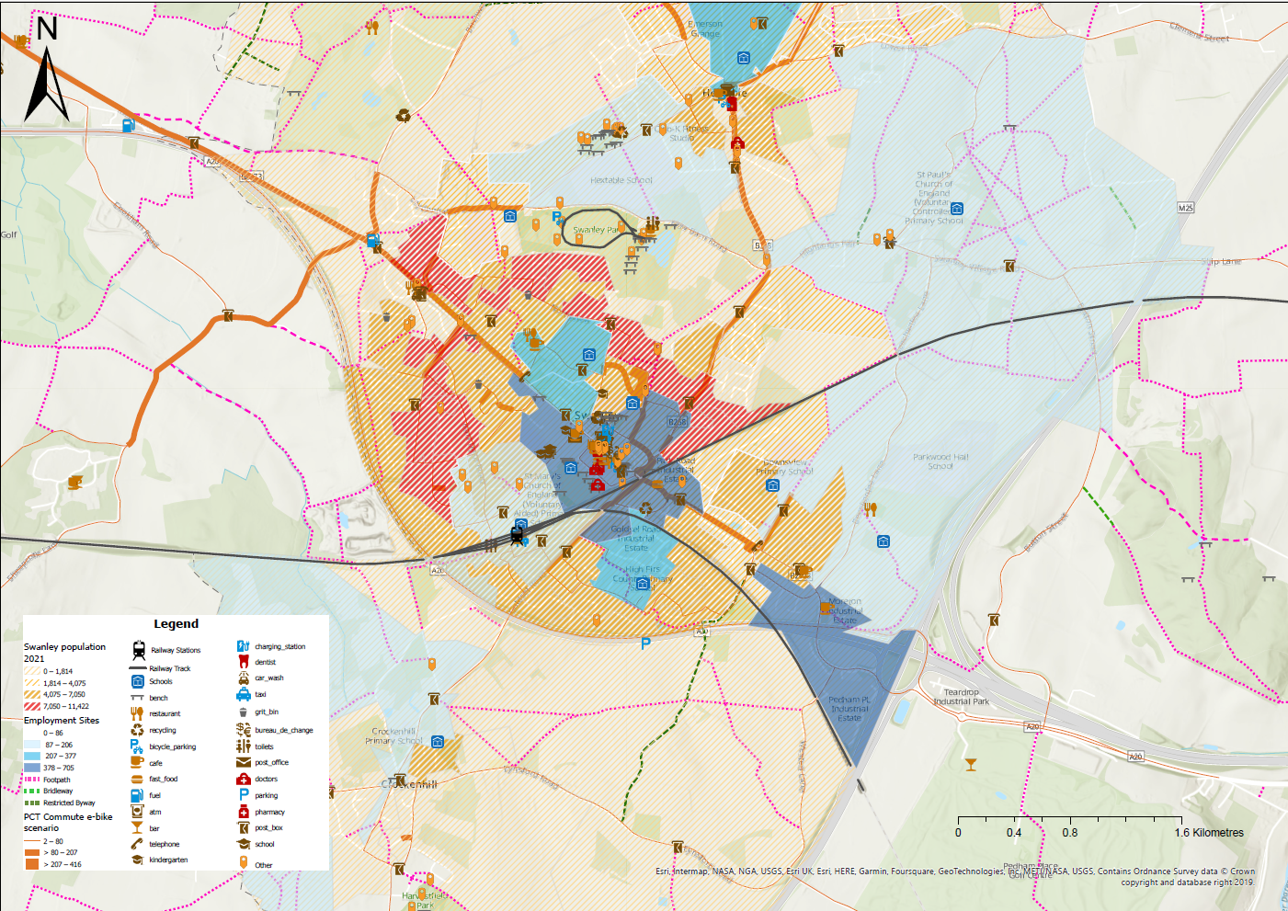
Community and stakeholder consultation
A series of consultations in June 2023 gathered feedback from councillors and the public on barriers to walking and cycling and potential cycle and walking routes for Swanley. By overlapping the different routes and barriers it is possible to identify hot spots where most of the potential routes or existing barriers are located.
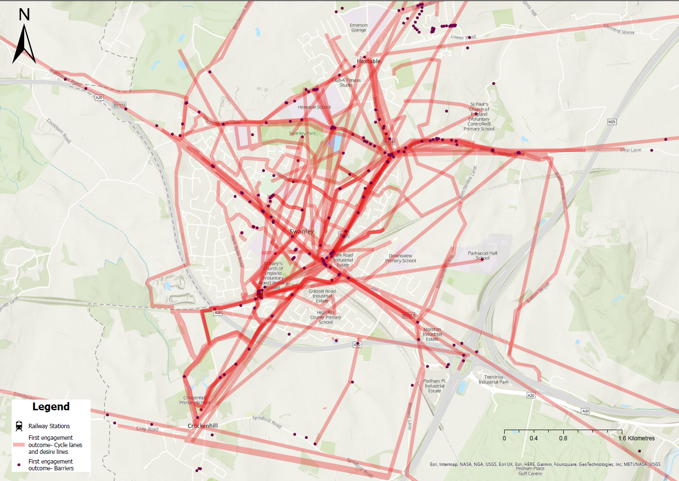
Clusters and desire lines
Further to the initial mapping exercise, the origin and destination points within proximity to each other have been clustered to simplify the analysis.
Once the key clusters were identified, direct desire lines were drawn connecting the clusters to identify the principal links to be provided by the cycle and walking network. This forms the skeleton of the cycle and walking network.
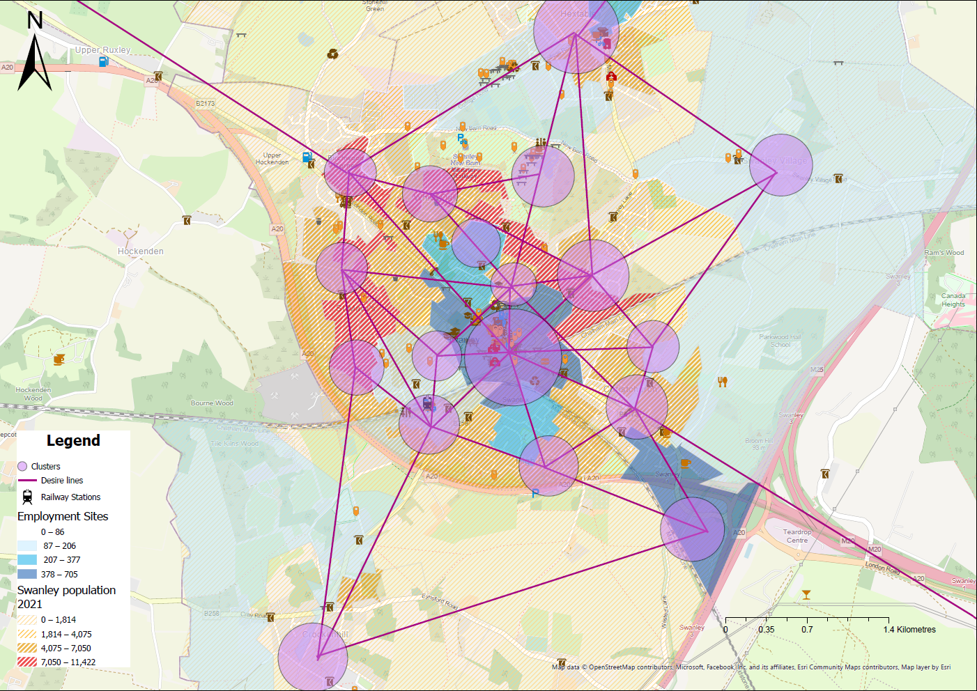
Swanley draft LCWIP cycle network
As a result of the previous analysis, a draft cycle network was drawn. In some cases, different cycle routes options are presented to reach the same destination. The purpose of this second round of engagement is to determine which routes are more popular within the community.

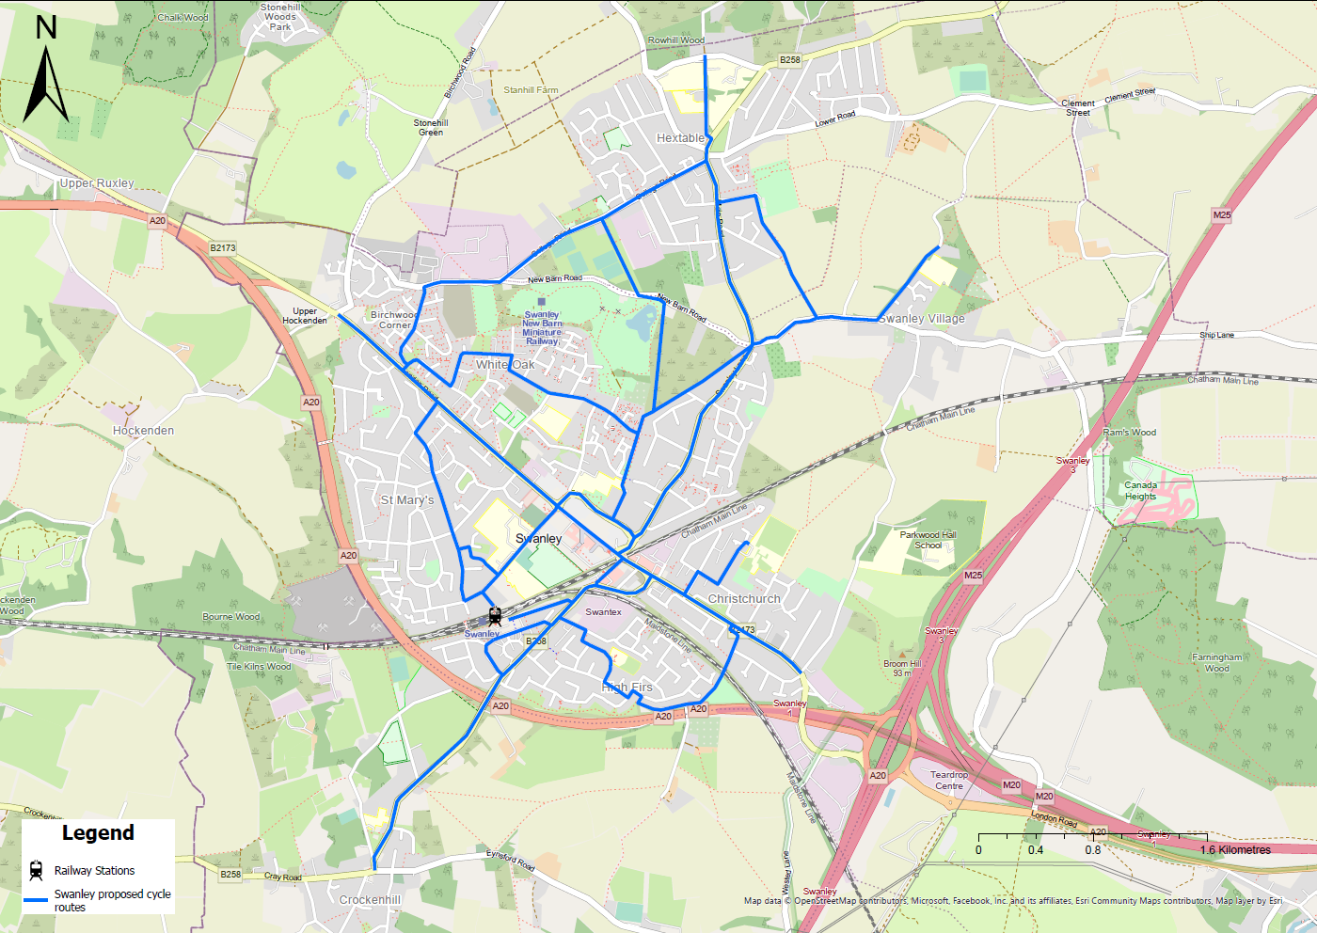
Swanley draft LCWIP walking network
Same as the draft cycle network, the draft walking network was developed from the mapping analysis. One of the differences from the Cycle network is that a Core Walking Zone (CWZ) (areas that normally consist of several walking trip generators that are located close together) was identified in the town centre.
