Otford to Sevenoaks Walking, Wheeling & Cycling Route
Overview
Sevenoaks District Council and Kent County Council are working together to develop a new walking, wheeling and cycling route that connects the heart of Otford to Sevenoaks, allowing residents to travel by a safe, attractive and sustainable means as an alternative to using their cars for short journeys.
The route connects Otford village centre to Bat and Ball junction, linking local attractions such as Otford Palace and Palace Park Wood with key commercial spots including Sainsbury's, Aldi, McDonald's, and Riverside retail park.
The route is part of our wider plan to create a network of safe and attractive walking and cycling routes and will complement the Sevenoaks East to West route, which is currently being built.
You can view the plans at two in-person drop-in sessions:
- Tuesday 17 June from 2pm to 5pm at Otford Village Memorial Hall; and
- Monday 7 July from 5pm to 8pm at the Luggage Room, Bat and Ball train station.
Your views and local knowledge will help inform and shape the project before designs are finalised. Staff from the Council and the designers will be on hand to hear your views and answer questions.
The consultation will be open from Friday 6th June for a period of six weeks. All comments must be submitted no later than 11:59pm on Friday 18th July 2025.
If you have any queries, please contact our Strategic Planning Team by emailing planning.policy@sevenoaks.gov.uk or calling 01732 227000.

Overview of the route
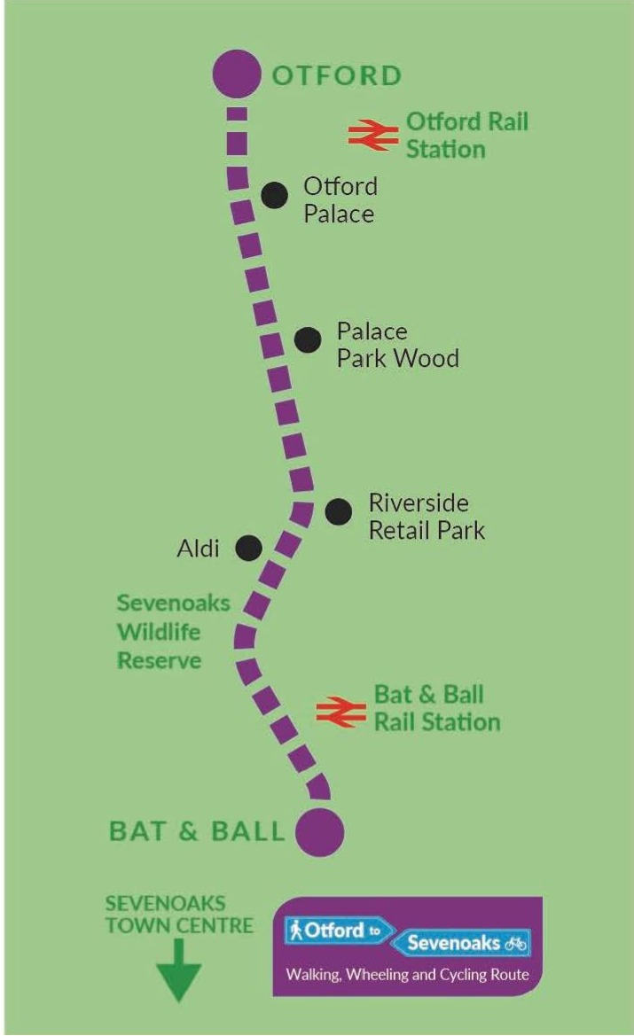

About your journeys
Firstly, we would like to know a little about your current journeys between Otford and Sevenoaks.
- How do you usually travel between Otford and Sevenoaks and how often?

Please tick one option for the transport mode e.g. Cycling for pleasure - once a week
Transport Mode | Every day or nearly every day | 2-5 days a week | Once a week | Less often but at least once a month | Less often than once a month | Never
Walking or wheeling (using a wheelchair) to get to/from work or school | ☐ | ☐ | ☐ | ☐ | ☐ | ☐
Walking or wheeling (using a wheelchair) for pleasure | ☐ | ☐ | ☐ | ☐ | ☐ | ☐
Cycling to get to/from work or school | ☐ | ☐ | ☐ | ☐ | ☐ | ☐
Cycling for pleasure | ☐ | ☐ | ☐ | ☐ | ☐ | ☐
Car, van or motorcycle to get to/from work or school | ☐ | ☐ | ☐ | ☐ | ☐ | ☐
Car, van or motorcycle for pleasure | ☐ | ☐ | ☐ | ☐ | ☐ | ☐
Public transport (e.g bus, taxi, train) to get to/from work or school | ☐ | ☐ | ☐ | ☐ | ☐ | ☐
Public transport (e.g bus, taxi, train) for pleasure | ☐ | ☐ | ☐ | ☐ | ☐ | ☐

- What stops you from walking, wheeling or cycling more often?
Please tick one option for the reason e.g. I don't have access to a bike - Disagree
Reason | Strongly Agree | Agree | Neither agree or disagree | Disagree | Strongly Disagree
I don't have access to a bike | ☐ | ☐ | ☐ | ☐ | ☐
Using a car or public transport is easier/quicker | ☐ | ☐ | ☐ | ☐ | ☐
The places I want to travel to are too far away to walk, wheel or cycle | ☐ | ☐ | ☐ | ☐ | ☐
Fear of being involved in a collision | ☐ | ☐ | ☐ | ☐ | ☐
I don't feel safe cycling on the road | ☐ | ☐ | ☐ | ☐ | ☐
Poorly maintained road, footpath or cycle lane surfaces | ☐ | ☐ | ☐ | ☐ | ☐
Lack of cycle routes or footpaths | ☐ | ☐ | ☐ | ☐ | ☐
I don't have anywhere safe to store a bicycle at home or at my destination | ☐ | ☐ | ☐ | ☐ | ☐
Health reasons | ☐ | ☐ | ☐ | ☐ | ☐
I don't feel confident enough to cycle | ☐ | ☐ | ☐ | ☐ | ☐
The weather | ☐ | ☐ | ☐ | ☐ | ☐
I don’t feel safe walking, wheeling or cycling on my own | ☐ | ☐ | ☐ | ☐ | ☐
Nothing stops me from walking, wheeling or cycling more often | ☐ | ☐ | ☐ | ☐ | ☐
Another reason | ☐ | ☐ | ☐ | ☐ | ☐
If you have selected 'another reason' please provide details here:

- How much do you agree that the following would encourage you to walk, wheel or cycle more often?
Please tick one option for the reason e.g. Saving money on transport costs - Agree
Reason | Strongly Agree | Agree | Neither agree or disagree | Disagree | Strongly Disagree
Saving money on transport costs | ☐ | ☐ | ☐ | ☐ | ☐
Getting more exercise /improving my health | ☐ | ☐ | ☐ | ☐ | ☐
Knowing I am helping the environment | ☐ | ☐ | ☐ | ☐ | ☐
New footways or cycle facilities | ☐ | ☐ | ☐ | ☐ | ☐
Separating facilities to cycle or walk on away from traffic | ☐ | ☐ | ☐ | ☐ | ☐
Routes that are more direct to my desired destination | ☐ | ☐ | ☐ | ☐ | ☐
More lighting for travelling at night | ☐ | ☐ | ☐ | ☐ | ☐
Seeing more people walking or cycling | ☐ | ☐ | ☐ | ☐ | ☐
Better maintained existing roads, footways or cycle paths | ☐ | ☐ | ☐ | ☐ | ☐
A more attractive environment to travel around | ☐ | ☐ | ☐ | ☐ | ☐
Nothing would encourage me to walk, wheel or cycle more | ☐ | ☐ | ☐ | ☐ | ☐
Another reason | ☐ | ☐ | ☐ | ☐ | ☐

If you have selected 'another reason' please provide details here

Your Views
The route connects Otford village centre to Bat and Ball junction, linking local attractions such as Otford Palace and Palace Park Wood with key commercial spots including Sainsbury's, Aldi, McDonald's, and Riverside retail park.
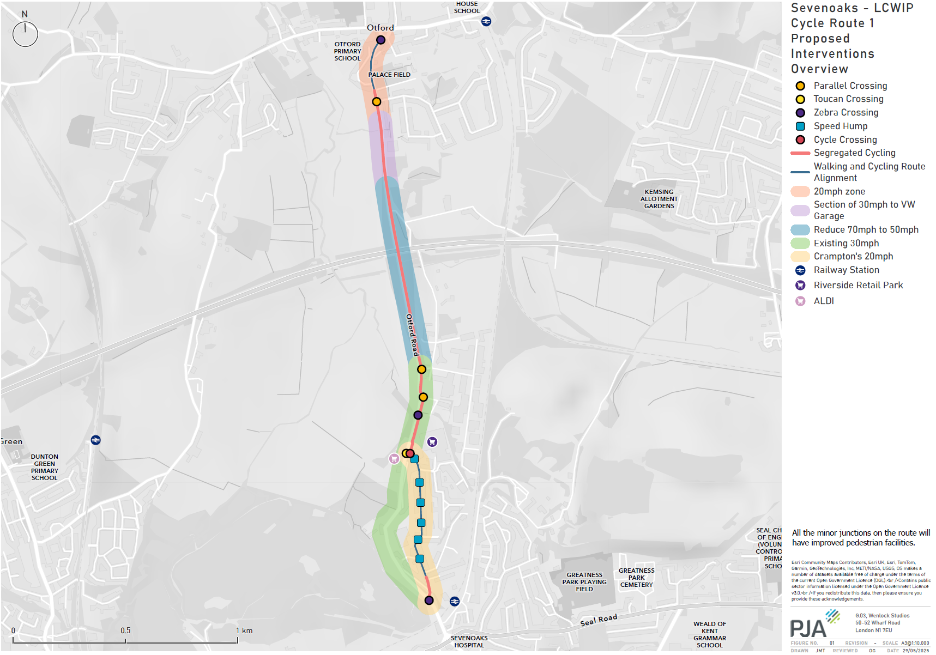
- To what extent do you agree with the proposed improvements for walking, wheeling and cycling from Otford to Sevenoaks?
☐ Strongly Agree
☐ Agree
☐ Neither agree or disagree
☐ Disagree
☐ Strongly Disagree
5. Would you use the proposed route for walking, wheeling or cycling?
☐ Yes
☐ No
☐ I don't know
6. Do you have any further comments about the proposed walking, wheeling and cycling improvements from Otford to Sevenoaks?

7. Do you wish to comment on the Technical Drawings?
☐ Yes
☐ No

The technical drawings can be viewed online:
www.sevenoaks.gov.uk/wwc
Due to the size and detail of the technical drawings, they are not included in this printed survey. Hard copies are also available for public viewing at:
- Sevenoaks District Council, Council Offices, Argyle Road, Sevenoaks, Kent, TN13 1HG
- Monday to Thursday - 8.45am to 5pm
- Friday - 8.45am to 4.45pm

8. Do you have any comments about the technical drawing 1 for the proposed walking, wheeling and cycling improvements from Otford to Sevenoaks?

9. Do you have any comments about the technical drawing 2 for the proposed walking, wheeling and cycling improvements from Otford to Sevenoaks?

10. Do you have any comments about the technical drawing 3 for the proposed walking, wheeling and cycling improvements from Otford to Sevenoaks?

11. Do you have any comments about the technical drawing 4 for the proposed walking, wheeling and cycling improvements from Otford to Sevenoaks?

12. Do you have any comments about the technical drawing 5 for the proposed walking, wheeling and cycling improvements from Otford to Sevenoaks?

13. Do you have any comments about the technical drawing 6 for the proposed walking, wheeling and cycling improvements from Otford to Sevenoaks?

14. Do you have any comments about the technical drawing 7 for the proposed walking, wheeling and cycling improvements from Otford to Sevenoaks?

15. Do you have any comments about the technical drawing 8 for the proposed walking, wheeling and cycling improvements from Otford to Sevenoaks?

16. Name and Organisation
First name (Required):
Surname (Required):
If you are responding on behalf of an organisation, please enter the name of the organisation here:
School and Year Group (for student use only):
17. Email address:
18. If you do not use email, please provide your postal address.
Postal address:
18. How do you describe your gender?
☐ Female
☐ Male
☐ Prefer not to say
☐ In another way (please specify)
If you describe your gender in another way, please type your answer:

19. Are you over the age of 18?
(Required)
☐ Yes
☐ No
20. How old are you?
(Required)
☐ 0-11
☐ 12-17
☐ 18-24
☐ 25-34
☐ 35-44
☐ 45-54
☐ 55-64
☐ 65 and over
☐ I'd prefer not to say
21. Do you consider yourself to have a disability?
☐ Yes
☐ No
☐ Prefer not to say
22. Please state the type(s) of impairment that applies to you.
☐ None - I do not have a disability
☐ Sensory impairment (such as being blind / having a visual impairment or being deaf / having a hearing impairment)
☐ Learning disability (such as Downs syndrome or dyslexia) or cognitive impairment (such as autism or head-injury)
☐ Mental health condition (such as depression or schizophrenia)
☐ Long-standing illness or health condition (such as cancer, HIV, diabetes, chronic heart disease, or epilepsy)
☐ Prefer not to say
☐ Other
If you have selected 'other' please provide details here:

23. If you live in Sevenoaks District, which Town or Parish do you live in?
☐ I don't live in the District
☐ Ash-cum-Ridley
☐ Badgers Mount
☐ Brasted
☐ Chevening
☐ Chiddingstone
☐ Cowden
☐ Crockenhill
☐ Dunton Green
☐ Edenbridge
☐ Eynsford
☐ Farningham
☐ Fawkham
☐ Halstead
☐ Hartley
☐ Hever
☐ Hextable
☐ Horton Kirby & South Darenth
☐ Kemsing
☐ Knockholt
☐ Leigh
☐ Otford
☐ Penshurst
☐ Riverhead
☐ Seal
☐ Sevenoaks Town
☐ Sevenoaks Weald
☐ Shoreham
☐ Sundridge with Ide Hill
☐ Swanley
☐ Westerham
☐ West Kingsdown
24. Please confirm that you agree to your comments being published and attributed by name and organisation (if applicable)
☐ I confirm that my comments can be publish and attributed by my name and organisation (Required)

