**Sevenoaks Town East to West Walking, Wheeling & Cycling Route**

**FAQs**

**Q1. How long is the route?**

A1. The route is approximately 2.4 miles long.

**Q2. Can the funding be used for other transport improvements, for example, improving roads or subsidising school buses?**

A2. The funding has been granted by Active Travel England specifically for the delivery of the route so cannot be used on other transport improvement works. Active Travel England is the government’s executive agency responsible for making walking, wheeling and cycling the preferred choice for everyone to get around in England.

**Q3. Why are you doing another public consultation on the route?**

A3. In June 2023 we sought your views on proposals to create a safe and attractive walking, wheeling and cycling route connecting the east and west of Sevenoaks town, encouraging residents to walk, wheel and cycle safely as an alternative to using the private car for short journeys.

The purpose of the consultation was to understand and incorporate the views of the local community, stakeholders, school children and their parents, and commuters, into the design of the scheme.

We received 490 responses, with 61% supporting the proposed improvements. However, there were also concerns raised with the Bradbourne Park Road and St James's Road sections of the route, with these sections not being supported.

You can view the full results of the June 2023 consultation here: <https://www.sevenoaks.gov.uk/wwc>.

We have therefore revised the design to overcome the issues raised through the consultation and are now asking for your views on the revised sections of the route, so that we can finalise it ready for construction later this year.

**Q4. How has the route changed?**

A4. The June 2023 consultation proposed a route that utilised Clockhouse Lane, Bradbourne Park Road and St James Road, but the proposals for these sections of the route were not supported.

The revised route makes use of Cavendish Avenue, Oakdene Road and Bradbourne Vale Road instead.

The remainder of the route remains the same as previously consulted on.

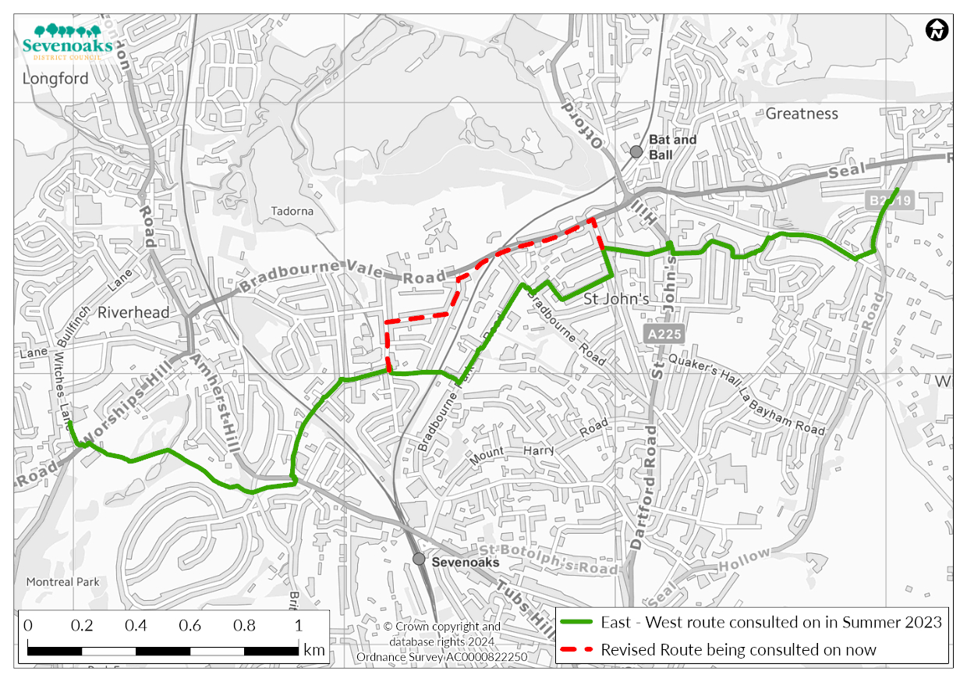

**Q5. How will the delivery of the route impact road users and levels of traffic?**

A5. The route will provide a safe and attractive environment for walkers, wheelers and cyclists, providing an alternative to using the private car for short journeys. It makes use of existing pavements where possible and adds cycling provision to some roads. All roads utilised by the route will remain open to vehicular traffic. There is therefore no expected impact on traffic flows and it is hoped that some road users will change their behaviour and use the route once it is delivered, contributing to a reduction in traffic flows in the longer term. The changes to the A25 will result in a loss of the slip lane to Bradbourne Road.

**Q6. Will the delivery of the route impact surrounding roads used for parking or as a cut through by parents during school drop off and pick up times?**

A6. The scheme is designed to encourage more local school related travel to be completed on foot, wheels or bicycle, thereby reducing the number of vehicles and pressure for parking and using cut throughs.

**Q7. Will the delivery of the route result in the loss of on-street car parking?**

A7. Seven on-street car parking spaces will be lost at the junction of Bradbourne Road and Bradbourne Vale Road, however these will be relocated on Bradbourne Vale Road. An additional six on-street car parking spaces will also be provided along Bradbourne Vale Road, resulting in a net increase in on-street car parking overall.

The scheme will encourage less reliance on private cars for school related journeys through promoting the use of walking, wheeling and cycling to reduce the ever growing problem with parking, congestion and health issues.

**Q8.** **Have safety concerns for the Riverhead Parkland section of the route been considered?**

A8. The route through Riverhead Parkland will provide the width required for cyclists including the wobble room when travelling and the remaining space available for pedestrians.

In general cyclists are not allowed to use public footpaths and therefore the existing route will be upgraded to a ‘bridleway’ or ‘cycle lane’ to legally allow cyclists to use this route.

To facilitate the use of cyclists, it is proposed to upgrade the width of the existing path to a minimum of 3 metres which is considered sufficient for cyclists to pass pedestrians comfortably.

Cyclists always wobble or wander from side to side in order to keep balance, particularly at lower speeds or going up hills. The width provision is sufficient to allow a typical male adult cycling and wobble room (250mm + 750mm = 1m) to pass pedestrians (2m spare width).

The below image (taken from the national Cycle Manual) illustrates this.

The construction of the path will be made into ‘tarmac’ and will fully utilise the available space. The existing path is made difficult with undulating surfaces (root damage), vegetation overgrowth and soil build-up which will be treated as part of the build proposal.

Cycling along the route, although not permitted, is currently used by school aged children accompanied by parents.

The purpose of this scheme is to promote more cycle and walking activities to tackle illness as an outcome of physical inactivity. The benefits of the scheme to be drawn from the reductions in premature deaths with large consequent savings in terms of health and knock–on benefits to the economy. As such, an ongoing campaign to promote the fair use of these facilities to be promoted in the local schools it serves and via tool kits the promoters Sevenoaks District Council and Kent County Council will provide as a feature of the scheme. Similar toolkits were developed for promoting 20mph schemes in Kent.

In addition, the scheme will be reviewed on an annual basis with surveys of the scheme users to determine the impact to perception of safety of the scheme.

In general, the proposal aims to retain all trees along this section of the route. The construction works will involve treating tree root areas to maximise the available space for walking, wheeling and cycling. At locations in which the tree root is causing severe damage to the path, these will be removed and replaced based on the asset value. i.e. 1 tree removal may result in 2 new trees planted in the vicinity of the scheme.

The review of the route so far does not indicate any significant impact to the existing biodiversity owing to the route following the existing path.

**Q9. Is the route safe for pedestrians?**

A9. According to Cycling UK (<https://www.cyclinguk.org/briefing/cycling-and-pedestrians#:~:text=Yet%2C%20although%20people%20who%20cycle,are%20hit%20by%20motor%20vehicles>) the percentage risk to pedestrians killed or seriously injured (KSI) is as low as 2%.

In Sevenoaks specifically, there has been one fatality of this nature in the last ten years (which occurred in 2013), and three in the entire record of collisions (1980, 1981 and 1984).

During the period 1980-2022 there have been a total of 987 cycle fatalities in Kent meaning pedal cycles have caused fatalities injuries to pedestrians in less than 0.5% of cases.